1 - League rules:
- 20 teams League
- 2 conferences
- 10 teams each
- Best 16 teams play the playoffs
- All play off games best of 5
- 28 weeks with 28 games:
If team1.conference == team2.conference :
games to be played between them = 2;
else : games to be played between them = 1;
meaning that every team plays 10 games against other conference teams, 1 game per team, and 18 games against same conference teams, 2 games per team
- Power ranknig by:
1 - Best Record ( W - D - L)
2 - Points Scored (Most)
3 - Points Allowed (Least)
4 - Turnovers (Least)
Playoff bracket:
Since we have 20 teams and only the best 16 teams qualify for the play offs, we'll have a bracket like this:
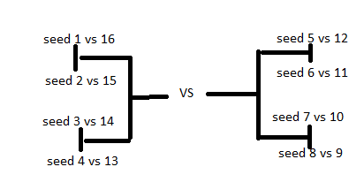

Draft:
-Players are drafted at 21 (22,23) meaning that between 21 years old and 23 years old the players could be drafted.
-Draft is 2 Rds
- To start, 10 Rd fantasy draft, if we were to think of rd as round this would mean that there will be 10 round fantasy drafts, if we were to think of think as a consumable currency, it means that to draft once, you need to spend 2 rds.
Teams Format:
- Teams play 8 players, minimum 4 plays total for each. For both offense and defense = 2 plays each.
- most plays a player can play is 16, 8 off and 8 def
- Teams have a total of 80 plays a game to manage. 40 per each half (devided among 8 starters)
- Teams can have up to 14 man roster constrained by salary cap and contract rights.
2 - Game Flow:
- Away Team gets the ball first
1- Random 1 of the 8 starting offensive players starters selected => Check Plays played + Planned.
2 - Random 1 of the 8 starting Defensive Players selected => Check plays played + planned.
3 - Off player chooses zone : Teams style or plan + hidden playstyle
4 - Positioning check : Defenders Positioning + RNG Dice Roll (on Play)
this = Bonus for offense on play.
Worst position + Dice Roll = Best Off Bonus from here on out.
Best Position + Dice roll = No bonus to Off from here or out on the play
5 - Foul Check = Def Awareness + zone (for selected zone) + personality type + off player personality type + Offensive boost from positioning check in step 4
if foul :
if Minor:
Give 2 foul shots
if Major :
Give 3 Foul Shots
(Minor and Major fould are determined through stat disparity)
- A foul is worth 2 points ( so 2, 4 or 6 points potential)
- A foul does not count as a play played.
- Play is over, start flow over
- Foul shot = Off+ Consistency + Awareness + shooting
6 - Juke vs Steal Check:
in Off = Control + Juking + zone + Positioning Bonus in Step 4
in Def = Guarding + steal + Zone
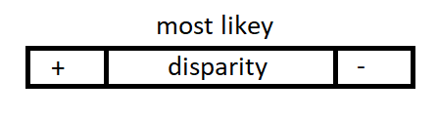
if Juke:
a - cut out defender
b - off player takes shot from current zone
c - Play Over
Else:
Skip to next step
if Steal:
a - Turnover for Off
b - Steal for Def
c - Play is over
7 - Shooting vs Pressure:
For Off : Control + Shooting Zone + Step 4 check overs + RNG dice Roll
For Def : Guarding + Pressure + Zone
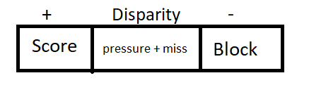
3 - Player Stats:
- Regular Stats values range from 10 to 99
- Hidden Stats values range flexibly and vary depending on teams in the league
Hybrid Affecting Stats:
- Consistency : Affects every equation
- Awarness : Positioning Check, Fouls, Foul Shots.
Offensive Stats:
- Juking : it Affects Juking Success.
- Control : Affects Juking and Shooting Success.
- Shooting : Affects Shooting Success
Deffensive Stats:
- Positioning : Affects Positioning Checks
- Steals : Steals Sucsess
- Guarding : Steals Success + Block Success.
- Pressure : Block Success.
Zone Stats:
- Inside : Inside Success for Off And Def
- Mid : Mid Success
- Outside : Outside Success.
Hidden Stats
- Learning : 1 - 5 : learn rate for Auto Points
- Longevity : 1 - 5 : Retire at 30 to 34
- Personality : 1 – 5: Bonus to Fouls, Contracts
- Zone Style : 1 - 12 : Question : How exactly are the calulations for that matrix made, i assume you multiply the zone style to the shooting stat when the player in inside a certain range, please correct me
4 - Pay:
- Total team salary cap: at least 350k adjustable
- Rookies enter the league at 10k for round 1 and 5k for round 2
- Player Salary Chart : (in the picture)
- Each re-sign phase a player with "this" overall stats expects that "pay"
1st and 2nd round draft pick need a FA phase
5 – League Flow
1.Fantasy Draft: To Start League.
2.Setup:
Set Depth Chart, Set Plays Planned, Set Starters, Set Coach Training
3.Play Season:
28 Weeks Games For 20 Team League: Play each team 2 times per inner conference and 1 time for non inner conference
Progression
Coach Training + Player Growth. Varies depending on teams in league, games played.

- Each Team Has 3 set coaches, you pick what they train, 2 drills minimum and per coach and 1 extra so 7 total drills from coaches
1 – Head Coach:
Can Train Any Stat
2 – Offensive Coach :
Can train offense stats, Can Train Zone Stats
3 – Defensive Coach :
Can Train Defense Stats, and Zone Stats
Player Growth:
- Potential under every player stat
- Hidden Learn Rate stat determines growth rate towards player’s potential, and this will occur some time during coach drills ( Drill every 4 weeks, 7 drills total)
- Points are distributed randomly acting as rng personal development

4.Play Post Season:
- Playoff Bracket on League Rules
- Playoff Meetings are best of 5 games. (3 to win)
5.End of Year Awards:
All Star Game, Best Players from each conference, Best of 3 Games
6.Off-Season:
- Aging phase (advance overalls)
- Retirement phase
-Resign Phase (with new expectations)
-Draft 2 rds (sign rookies)
- FA phase (free agency, 3 round, Bids Start at minimum expected pay)
-Finalize (Random Schedule Generator)
- Repeat

